Adel Sliman  
Visual Basic 681  
2/25/2019

**Semester Project Design**

My visual basic semester project will be a short game modeled after the Atari Space Invaders game. All of my Assets are free use or self-created. And the game is themed after Kingdom hearts’ Gummi Ship Missions with an 8-bit Spin to it. The Game will be Fairly simple. The user will start the application and be greeted with the main menu which they will then be able to start the game or close the program. Once the user starts, the game will load and the user will have to uses the W and D keys to maneuver the ship left and right respectively and fire at the heartless ships above (space invaders) with the Spacebar. If the Player is hit the game is over and after a short period of time, they will be taken to a high score screen where they can enter their name it will be added to the list of developer scores if they scored higher than the lowest score on the list.

The Players ship:

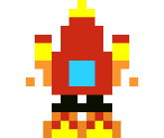

I made an 8-bit ship modeled after the Highwind, the ship used in kingdom hearts

The Background:



This background was making the program run really slow even with transparent backgrounds so now I just used a black screen

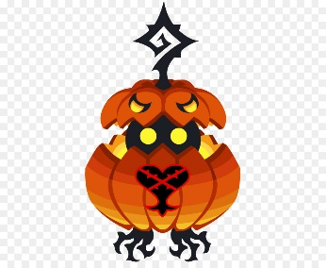The Enemy:

The same thing happened with this enemy so I instead of using this image I made own 8-bit sprite just like the attack and spaceship

Some screen shots of how my game is going to look.

